LAB REPORT – 5
PART A – SR LATCH

NAME : Basireddy Khyathi Sri
ROLL NO : 2023102065
GROUP : 6
TABLE : 3

Objective:
Assembling the NOR gate to make SR latch and observing its outputs by giving inputs.

Electronic Components Required:
1. Bread Board
2. CD4001 chip/74HC02 IC
3. Power Supply
4. Wires
5. LED bulbs

Reference Circuit:

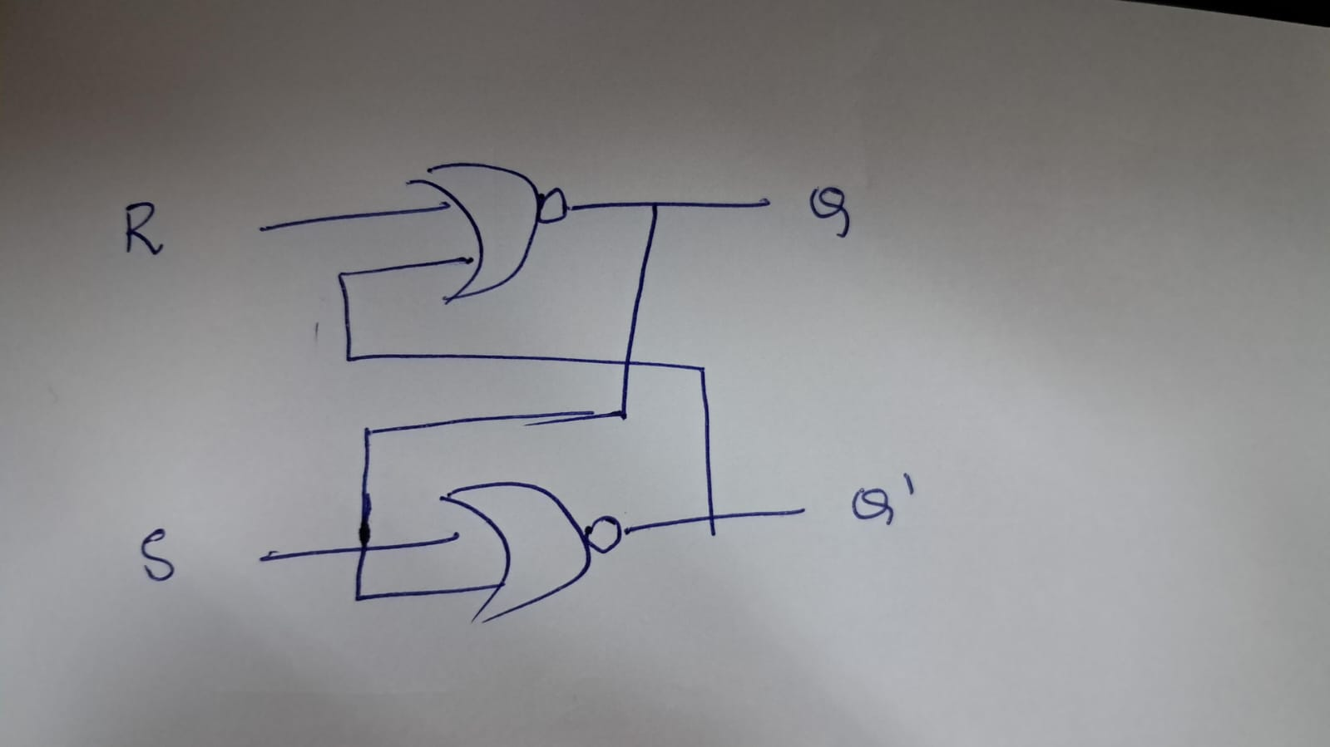

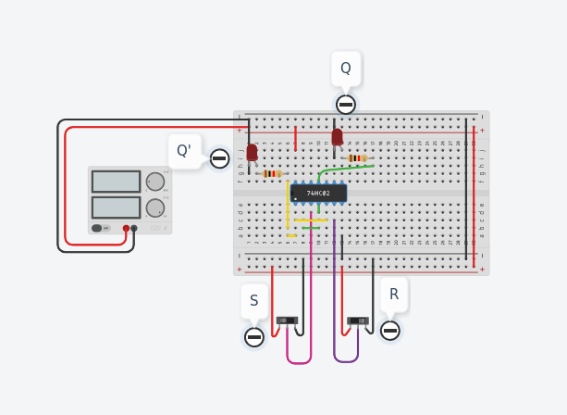
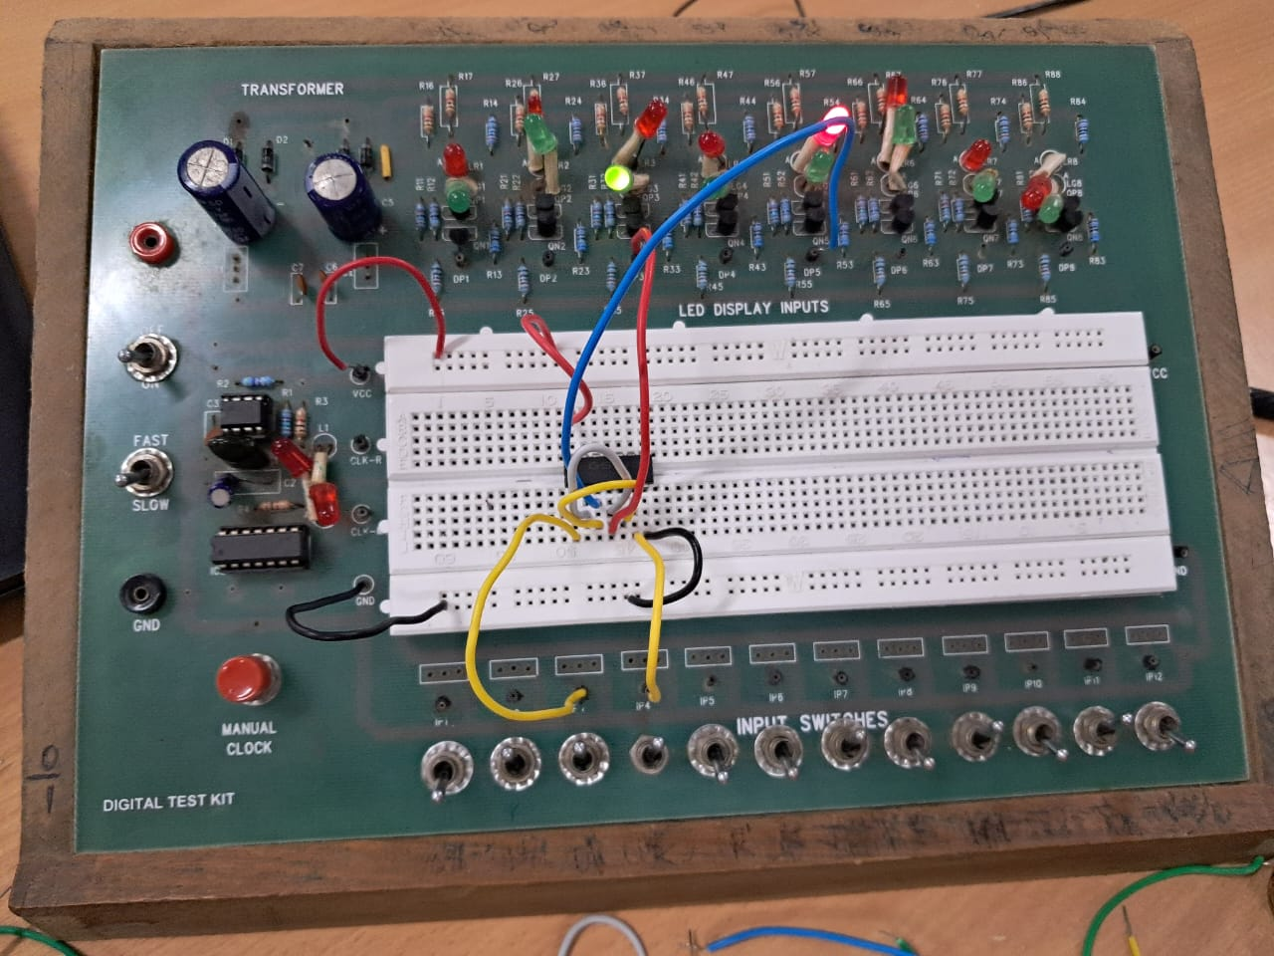

Procedure:
1. Take the inputs J and K to the two gates of the 4-input NAND gate.
2. Also give the clock inputs to the same.
3. Then connect the unused inputs to VCC.
4. Latch both the outputs from the 4-input NAND gate using a NAND latch formed by using a 2-input NAND IC.
5. Then give the outputs of the latch and the clock to two gates of the NOR IC.
6. Latch the outputs again, this time using a NOR latch formed by using a NOR IC.
7. Connect the final output Q and Q’ respectively to the gates containing K and J respectively.
8. Building a JK flip-flop is done.
9. The output for different inputs is given below.
10.Also Connect a push-button at Qm’ to reset the flip-flop.

Observations:
For various combinations of clock, J and K the following states and outputs are observed.

CLOCK | J | K | Q_{n+1} | STATE
0 | 0 | 0 | Q_{n} | -
0 | 0 | 1 | Q_{n} | -
0 | 1 | 0 | Q_{n} | -
0 | 1 | 1 | Q_{n} | -
1 | 0 | 0 | Q_{n} | Hold
1 | 0 | 1 | 0 | Reset
1 | 1 | 0 | 1 | Set
1 | 1 | 1 | Q_{n}’ | Toggle

Conclusion:
Therefore, RS latch is constructed successfully and
the changes in the outputs on the change of inputs
are observed.

TinkerCad Simulation:
https://www.tinkercad.com/things/jx4PK7uEhRu-rs-latcha-lab-5/editel?sharecode=BJtkMPKHrG9pfVdy2792XlhL1NK2P-Z1-mgb10hy2SI

PART B – JK FLIP-FLOP

Objective:
Assembling a JK flip flop using two 4-input NAND gates from a CD4012 chip as 3-input gates and observing the outputs for different inputs given.

Electronic Components Required:
1. Digital Test Kit
2. CD4012 chip
3. CD4001 chip
4. IC7400 chip
5. LED bulbs
6. Switches
7. Wires
8. Power Supply
9. Push Button

Reference Circuit:

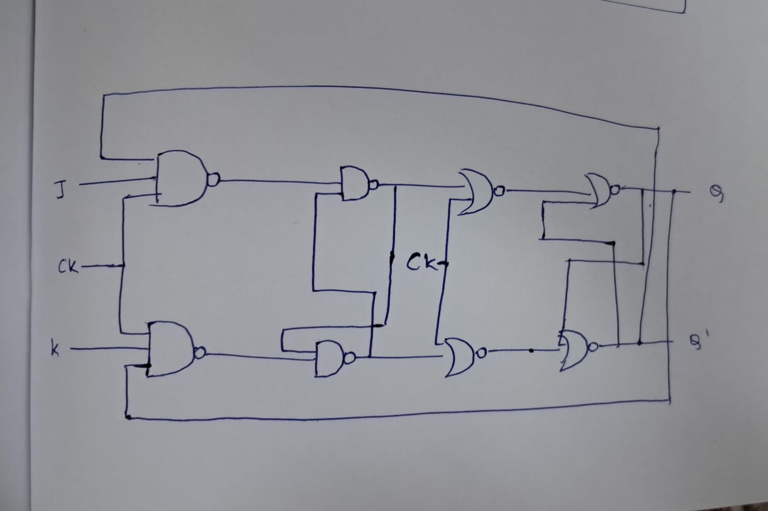

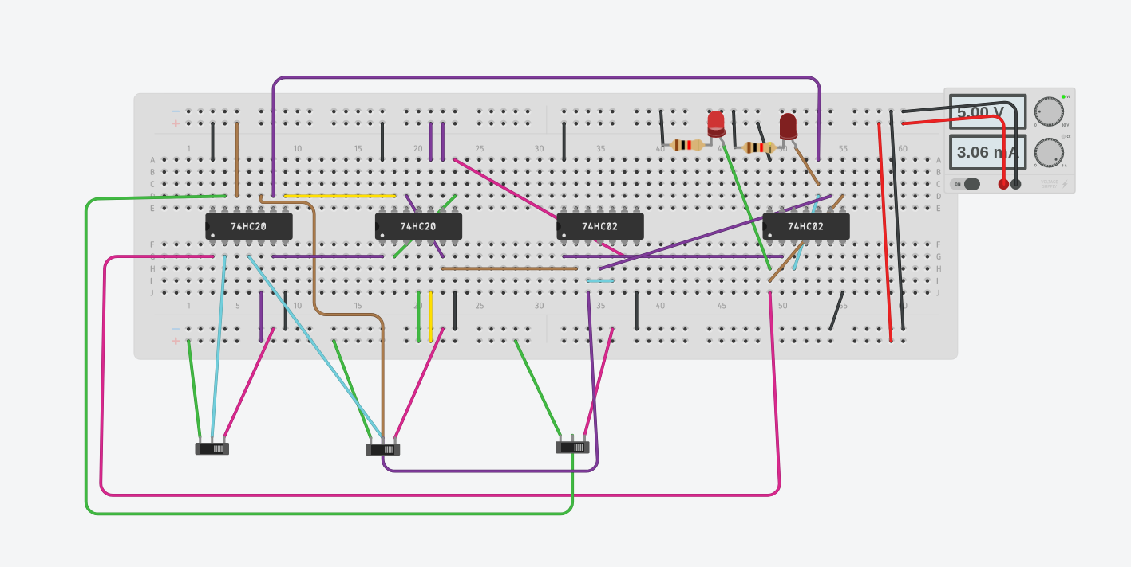

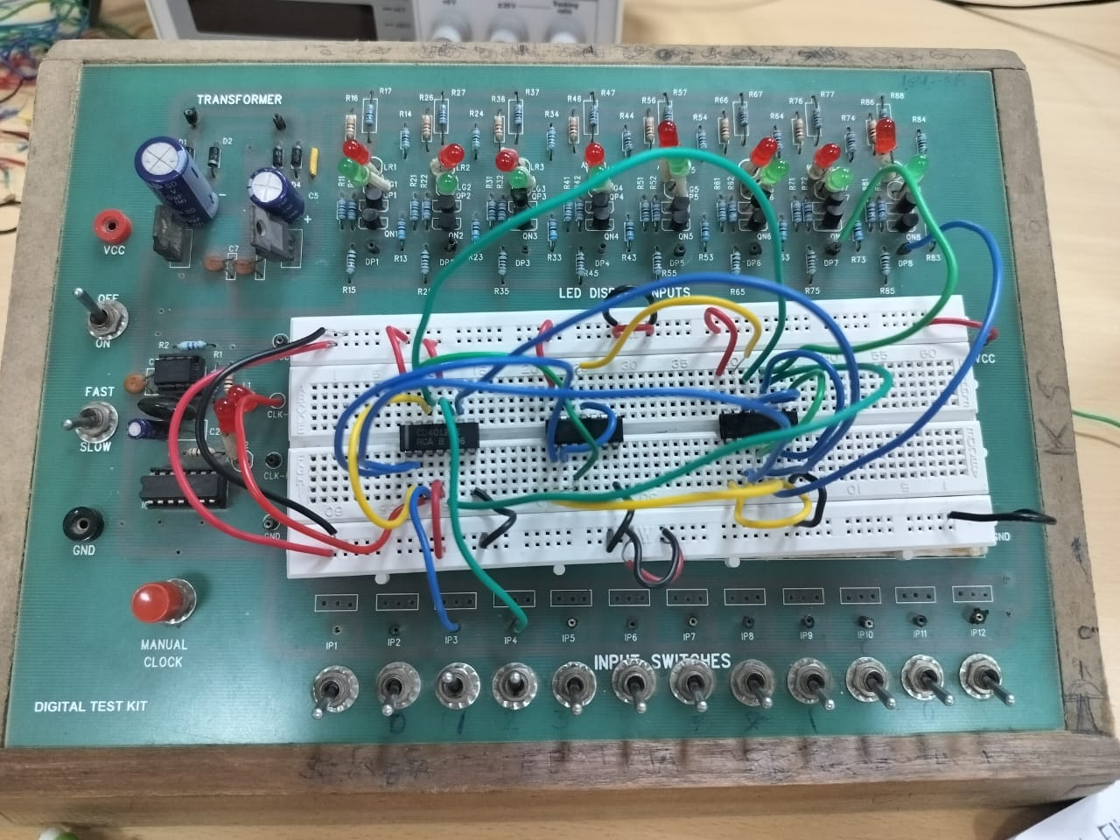

Procedure:
1. Connect the 5V / GND pins to the breadboard's +/-
columns to turn on the breadboard.
2. Take inputs directly from the slide switches.
3. Power them by placing the ICs on the breadboard.
4. The connections with NOR and NAND gates should be done
according to the below diagram.
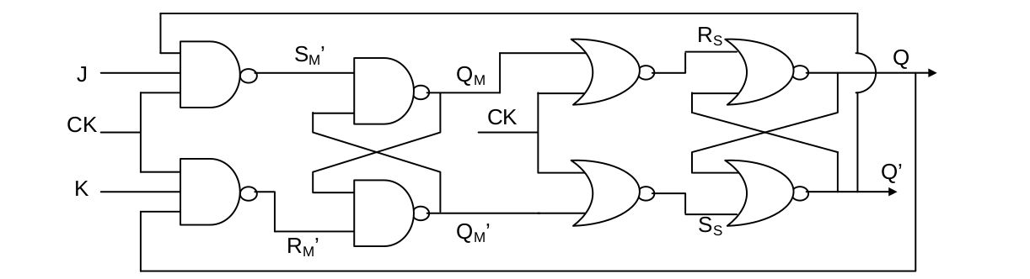
The output values correspond to the given equations below:
RM = K • Q • CK, SM = J • Q' • CK, SS = QM • CK' and RS =
QM' • CK'
5. For the first column of the circuit, use NAND gates with four
inputs. Connect the three inputs J, CLK, and VCC. And do
the same for K also.
6. Now, we pass an SR Latch (NAND) with the output values of
four-input NAND gates.
7. The latch's outputs are then each NORed with a CLK (third
column in the circuit).
8. Then, these NORed outputs are sent into a second SR Latch
(NOR) (fourth column in the circuit). Q and Q' are the final
results. Now, each fourth input port of the initial four NAND
gates should be connected to Q and Q'. (Q -> K, Q' -> J)
9. Also connect these outputs to LED outputs.

Observation:
We tabulate the following activities by doing calculations
using various J, K, and CLK combinations. And that is also
influenced by the clock (positive edge/negative edge).

J | K | ACTION | Q_{n+1}
0 | 0 | HOLD | Q
0 | 1 | CLEAR | 0
1 | 0 | SET | 1
1 | 1 | TOGGLE | Q

To verify all the values
S | R | Q | Q’
0 | 1 | 0 | 1
0 | 0 | 0 | 1
1 | 0 | 1 | 0
0 | 0 | 1 | 0
0 | 1 | 0 | 1
1 | 0 | 1 | 0
0 | 1 | 0 | 1
0 | 0 | 0 | 1
1 | 0 | 1 | 0
1 | 1 | 0 | 0
0 | 0 | 0/1 | 1/0
0 | 1 | 0 | 1
1 | 1 | 0 | 0
0 | 0 | 0/1 | 1/0

Conclusion:
We verified its working by comparing the outputs of different
combinations of inputs with the above table.

TinkerCad Simulation:

https://www.tinkercad.com/things/luttq1fKEbC-terrific-tumelo-fyyran/editel?sharecode=Kf-O1Qxyz93oHu1CoCcOHzn_4oRCLkWQDrBFRwY_Bu4

PART C – 4 BIT UP-DOWN ADDER

Objective:
To design a ripple counter that would count from 0 to 15
using Arduino Code

Electric Components Required:
• Battery
• Arduino UNO
• LED
• Resistor
• Breadboard
• Connecting wires

The Reference Circuit:

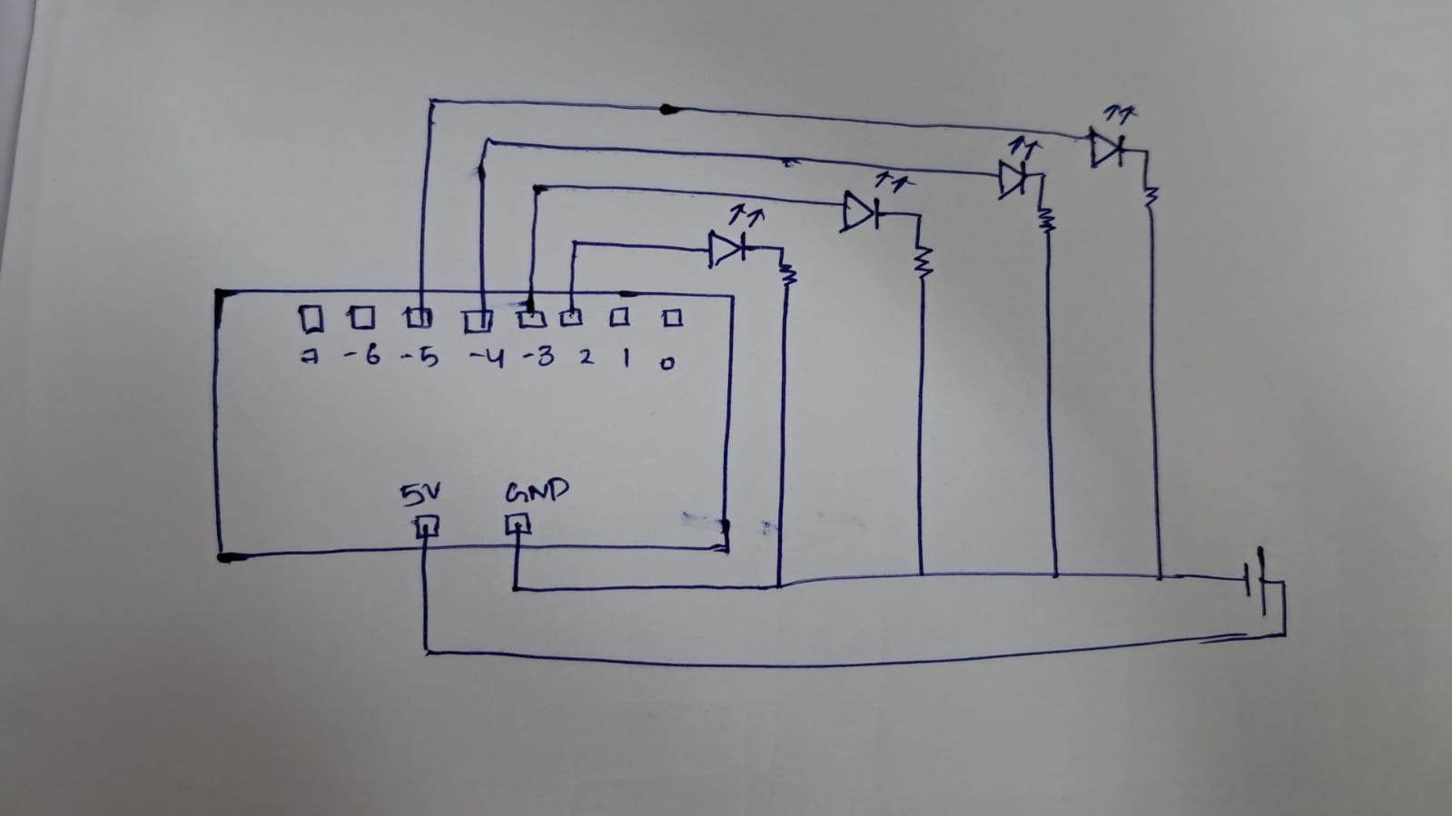

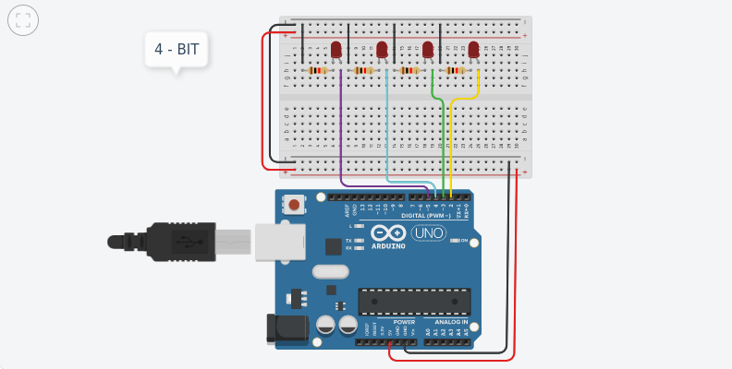

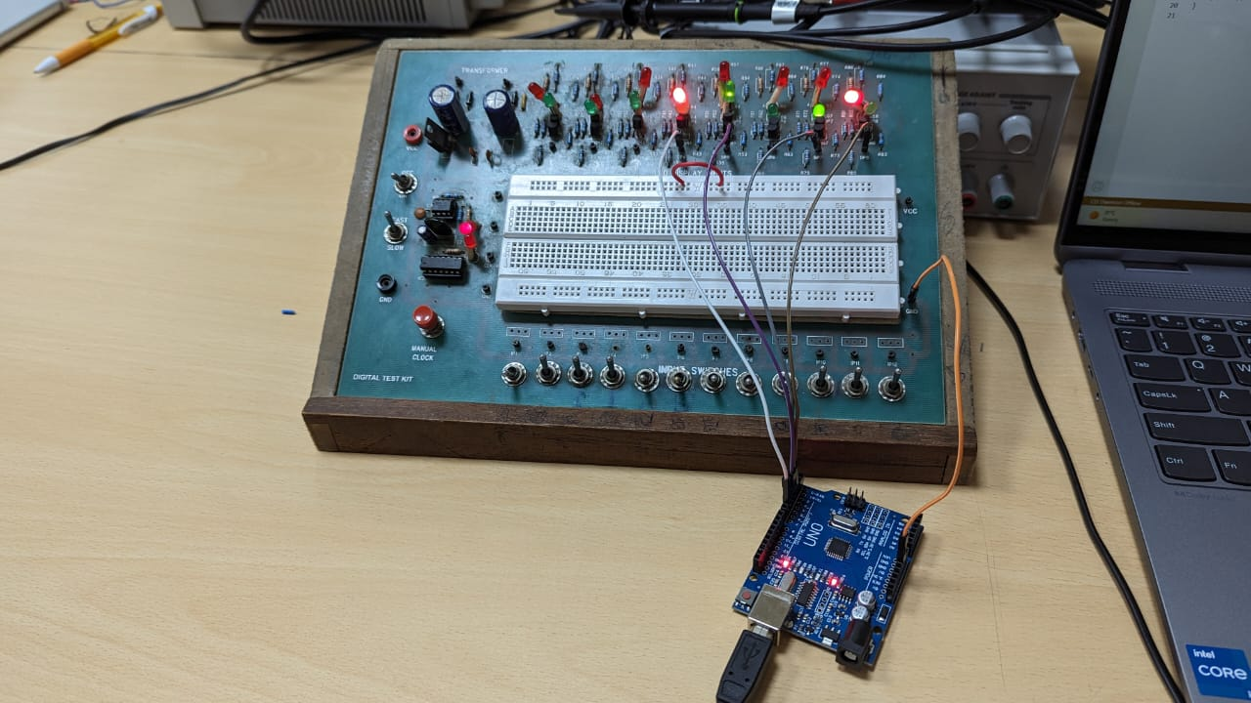
Procedure:
1) Write a code to program the Arduino in such a way, so as to glow a certain LED, after a particular time.
2) The code is given in the TinkerCad simulation.
3) Connect the LEDs and resistors in series accordingly.

CODE:

- #ifndef Event_h
- #define Event_h
- #include <inttypes.h>
- #define EVENT_NONE 0
- #define EVENT_EVERY 1
- #define EVENT_OSCILLATE 2
- class Event
- {
- public:
- Event(void);
- void update(void);
- void update(unsigned long now);
- int8_t eventType;
- unsigned long period;int repeatCount;
- uint8_t pin;
- uint8_t pinState;
- void (*callback)(void);
- unsigned long lastEventTime;
- int count;
- };
- #endif
- #ifndef Timer_h
- #define Timer_h
- #include <inttypes.h>
- #define MAX_NUMBER_OF_EVENTS (10)
- #define TIMER_NOT_AN_EVENT (-2)
- #define NO_TIMER_AVAILABLE (-1)
- class Timer
- {
- public:
- Timer(void);
- int8_t every(unsigned long period, void (*callback)(void));
- int8_t every(unsigned long period, void (*callback)(void), int repeatCount);
- int8_t after(unsigned long duration, void (*callback)(void));
- int8_t oscillate(uint8_t pin, unsigned long period, uint8_t startingValue);
- int8_t oscillate(uint8_t pin, unsigned long period, uint8_t startingValue, int repeatCount);
- /* This method will generate a pulse of !startingValue, occuring period after the
- * call of this method and lasting for period. The Pin will be left in !startingValue.
- */
- int8_t pulse(uint8_t pin, unsigned long period, uint8_t startingValue);
- /**
- * This method will generate a pulse of pulseValue, starting immediately and of
- * length period. The pin will be left in the !pulseValue state
- */
- int8_t pulseImmediate(uint8_t pin, unsigned long period, uint8_t pulseValue);
- void stop(int8_t id);
- void update(void);
- void update(unsigned long now);
- protected:
- Event _events[MAX_NUMBER_OF_EVENTS];
- int8_t findFreeEventIndex(void);
- };
- #endif
- //// YOUR CODE STARTS HERE
- Timer t;
- int count = 0;
- int state = 0;
- // "every" X milliseconds
- void stopAllTimers() {
- t.stop(3);
- t.stop(2);
- t.stop(5);
- t.stop(4);
- t.stop(1);state = state == 0 ? 1 : 0;
- t.oscillate(2, 500, state);
- t.oscillate(3, 1000, state);
- t.oscillate(4, 2000, state);
- t.oscillate(5, 4600, state);
- }
- void setup() {
- Serial.begin(9600);
- pinMode(2, OUTPUT);
- pinMode(3, OUTPUT);
- pinMode(4, OUTPUT);
- pinMode(5, OUTPUT);
- t.every(8000, stopAllTimers);
- t.oscillate(2, 500, state);
- t.oscillate(3, 1000, state);
- t.oscillate(4, 2000, state);
- t.oscillate(5, 4600, state);
- }
- /* // starts from high, oscillates on the pin every 500ms
- int eventId = t.oscillate(pin, 500, HIGH);
- if (eventId < 0) {
- Serial.println("Could not initialize timer");
- }
- } */
- // 1 unit of your timer = 500ms in real time
- void loop() {
- t.update();
- }
- //// YOUR CODE ENDS HERE// For Arduino 1.0 and earlier
- // #if defined(ARDUINO) && ARDUINO >= 100
- // #include "Arduino.h"
- // #else
- // #include "WProgram.h"
- // #endif
- Event::Event(void)
- {
- eventType = EVENT_NONE;
- }
- void Event::update(void)
- {
- unsigned long now = millis();
- update(now);
- }
- void Event::update(unsigned long now)
- {
- if (now - lastEventTime >= period)
- {
- switch (eventType)
- {
- case EVENT_EVERY:
- (*callback)();
- break;
- case EVENT_OSCILLATE:
- pinState = ! pinState;
- digitalWrite(pin, pinState);
- break;
- }
- lastEventTime = now;count++;
- }
- if (repeatCount > -1 && count >= repeatCount)
- {
- eventType = EVENT_NONE;
- }
- }
- Timer::Timer(void)
- {
- }
- int8_t Timer::every(unsigned long period, void (*callback)(), int repeatCount)
- {
- int8_t i = findFreeEventIndex();
- if (i == -1) return -1;
- _events[i].eventType = EVENT_EVERY;
- _events[i].period = period;
- _events[i].repeatCount = repeatCount;
- _events[i].callback = callback;
- _events[i].lastEventTime = millis();
- _events[i].count = 0;
- return i;
- }
- int8_t Timer::every(unsigned long period, void (*callback)())
- {
- return every(period, callback, -1); // - means forever
- }
- int8_t Timer::after(unsigned long period, void (*callback)())
- {return every(period, callback, 1);
- }
- int8_t Timer::oscillate(uint8_t pin, unsigned long period, uint8_t startingValue, int repeatCount)
- {
- int8_t i = findFreeEventIndex();
- if (i == NO_TIMER_AVAILABLE) return NO_TIMER_AVAILABLE;
- _events[i].eventType = EVENT_OSCILLATE;
- _events[i].pin = pin;
- _events[i].period = period;
- _events[i].pinState = startingValue;
- digitalWrite(pin, startingValue);
- _events[i].repeatCount = repeatCount * 2; // full cycles not transitions
- _events[i].lastEventTime = millis();
- _events[i].count = 0;
- return i;
- }
- int8_t Timer::oscillate(uint8_t pin, unsigned long period, uint8_t startingValue)
- {
- return oscillate(pin, period, startingValue, -1); // forever
- }
- /**
- * This method will generate a pulse of !startingValue, occuring period after the
- * call of this method and lasting for period. The Pin will be left in !startingValue.
- */
- int8_t Timer::pulse(uint8_t pin, unsigned long period, uint8_t startingValue)
- {
- return oscillate(pin, period, startingValue, 1); // once
- }
- /* This method will generate a pulse of startingValue, starting immediately and of
- * length period. The pin will be left in the !startingValue state
- */
- int8_t Timer::pulseImmediate(uint8_t pin, unsigned long period, uint8_t pulseValue)
- {
- int8_t id(oscillate(pin, period, pulseValue, 1));
- // now fix the repeat count
- if (id >= 0 && id < MAX_NUMBER_OF_EVENTS) {
- _events[id].repeatCount = 1;
- }
- return id;
- }
- void Timer::stop(int8_t id)
- {
- if (id >= 0 && id < MAX_NUMBER_OF_EVENTS) {
- _events[id].eventType = EVENT_NONE;
- }
- }
- void Timer::update(void)
- {
- unsigned long now = millis();
- update(now);
- }
- void Timer::update(unsigned long now)
- {
- for (int8_t i = 0; i < MAX_NUMBER_OF_EVENTS; i++)
- {
- if (_events[i].eventType != EVENT_NONE)
- {
- _events[i].update(now);}
- }
- }
- int8_t Timer::findFreeEventIndex(void)
- {
- for (int8_t i = 0; i < MAX_NUMBER_OF_EVENTS; i++)
- {
- if (_events[i].eventType == EVENT_NONE)
- {
- return i;
- }
- }
- return NO_TIMER_AVAILABLE;
- }

Observation:
We observe that the 4 LEDs glow in a binary way, in equal intervals of time.

TinkerCad Link:
https://www.tinkercad.com/things/2eMqEcNIu37-/editel?sharecode=F6BWsISuRD39i8kNLBkjYBqIXHkVnhBCqqJCht4VQJY

